ATTACHMENTS

1. Jane Fairburn’s deputation to the City of Toronto Executive Committee

https://www.youtube.com/watch?v=5r9yNm1YQzY&feature=youtu.be&t=1h23m57s

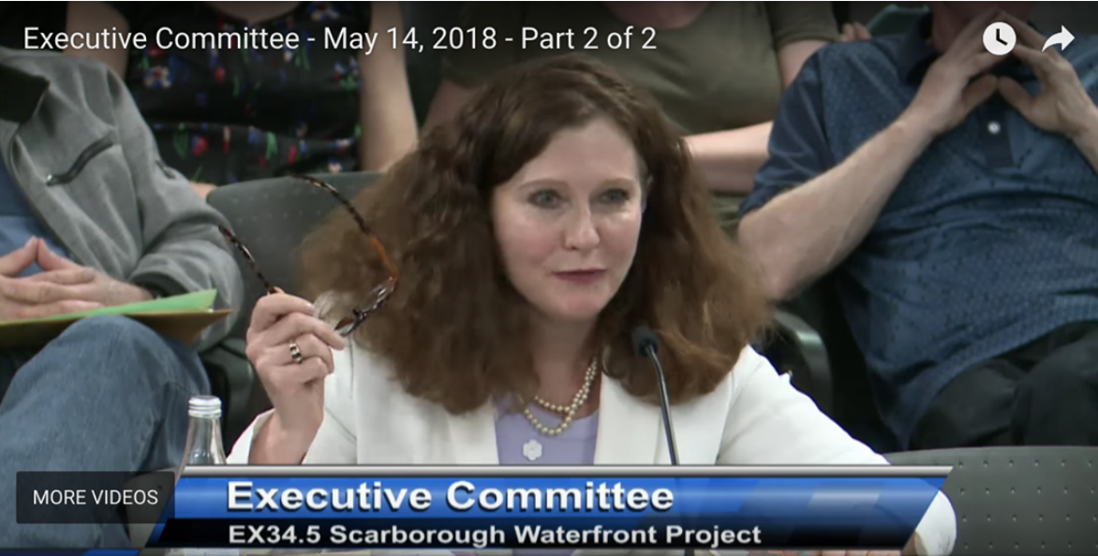

2. Jane Fairburn’s Correspondence and Media Interviews of the SWP

http://janefairburn.com/waterfront-correspondence/

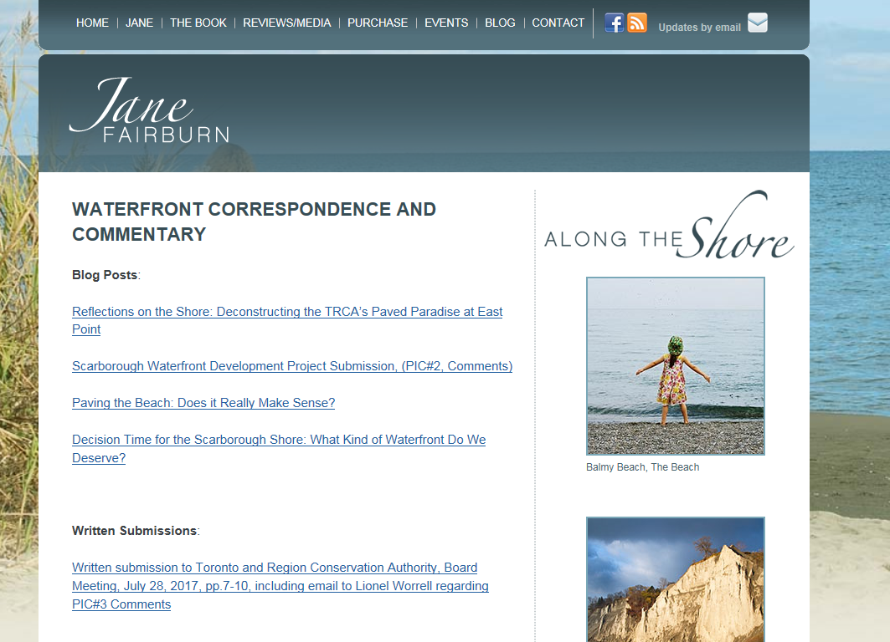

3. Mark Mattson’s deputation to the City of Toronto Executive Committee, President and Founder of Lake Ontario Waterkeeper

(Mark’s deputation is at 1:14:38):
https://www.youtube.com/watch?v=5r9yNm1YQzY&feature=youtu.be

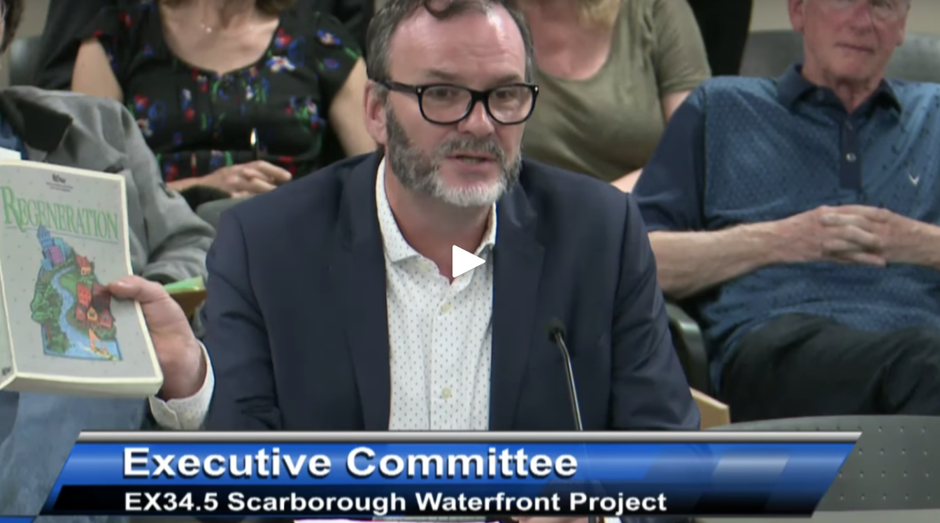

4. Nancy Gaffney’s email to Jane Fairburn, June 8m 2018

Sorry for the delay. I copied your email address wrong. My apologies.

Nancy Gaffney, BSc
Waterfront Specialist
Waterfront | Watershed Strategies Division

T: 416.661.6600 ext. 5313
E: ngaffney@trca.on.ca
C: 416.258.1409
A: 101 Exchange Ave, Vaughan, ON L4K 5R6

Toronto and Region Conservation Authority (TRCA) | trca.ca
----- Forwarded by Nancy Gaffney/MTRCA on 06/08/2018 10:27 AM -----

From: Nancy Gaffney/MTRCA
To: mjfairburn@rogers.com
Cc: "Sherri Lange" <kodaisl@rogers.com>, "Roy Wright" <rdwright471@rogers.com>, "Jennifer Falvy" <jenfalvy@hotmail.com>, "Kathleen Gillis" <kathleen.gillis@gmail.com>, Water Front/TRCA@MTRCA
Date: 06/07/2018 07:05 PM
Subject: Fw: Scarborough Waterfront Project -- Planning and Process Issues

Dear Ms. Fairburn,

As directed on several occasions, please direct all of your correspondence to waterfront@trca.on.ca. Failure to do this will result in a delayed response or worse your email may not be received.

The SWP EA was approved for submission to the MOECC on May 22 by City of Toronto Council. The Final EA is anticipated to be submitted on June 15, 2018 and will be made available for public review at the same time. Please refer to the following links for a more detailed discussion of the MOECC review process for Individual EAs.

https://www.ontario.ca/page/preparing-environmental-assessments#section-2

https://www.ontario.ca/document/preparing-and-reviewing-environmental-assessments-ontario-0

The following bullets summarize the MOECC review process:
The Final EA will be available for public review for 7 weeks ( June 15 to August 3). At the same time the MOECC will consult with Indigenous Communities, government agencies and other interested parties.
The MOECC will review all comments received and has 5 weeks to prepare and publish the MOECC review.

The public, government agencies, Indigenous communities or any other interested party has 5 weeks to provide comments to the ministry on the Ministry review‎. Once public comment is finished on the Ministry Review, the Minister has 13 weeks to make a decision.

After the project has been approved, the proponent will need to gather other approvals as needed.
Any time during the EA process, the proponent or any other interested persons can ask for mediation. It should be noted that the timelines for the MOECC review and Minister’s decision can be delayed if they are looking for more information from the proponent.

As you know, the City of Toronto has directed the TRCA to submit the EA and undertake further investigation of a number of issues in consultation with City staff and “in accordance with the commitments made within the Environmental Assessment, as part of the next stage of design and in keeping with the key Objectives and commitments of the Environmental Assessment.” To this end, the City of Toronto motions will be addressed by TRCA during the next stage of design which is the detailed design phase of the project. This will occur after EA approval is achieved and generally for project components starting in the west and proceeding to the east. The timing for detailed design will be dependent upon project funding availability.

During detailed design for the East Segment, environmental monitoring information collected since the completion of the EA and more specific engineering and technical data, such as updated erosion information will be reviewed against project plans. In addition, more detailed discussions of permitting requirements will be held with MNRF and discussions with industrial landowners will seek resolution of safety and security issues. These inputs will help TRCA in consultation with City staff determine if there are opportunities to change the design of the preferred alternative in the East Segment. If modifications are made to the design they will need to be reassessed in accordance with the EA Amendment process set out in Chapter 9 of the Final EA.

If you have further questions please contact me at waterfront@trca.on.ca.

Nancy

Nancy Gaffney, BSc
Waterfront Specialist
Waterfront | Watershed Strategies Division

T: 416.661.6600 ext. 5313
E: ngaffney@trca.on.ca
C: 416.258.1409
A: 101 Exchange Ave, Vaughan, ON L4K 5R6

Toronto and Region Conservation Authority (TRCA) | trca.ca

From: "M.Jane Fairburn" <mjanefairburn@rogers.com>
To: Lionel Worrell <LWorrell@trca.on.ca>
Cc: Sherri Lange <kodaisl@rogers.com>, Roy Wright <rdwright471@rogers.com>, Jennifer Falvy <jenfalvy@hotmail.com>, Kathleen Gillis <kathleen.gillis@gmail.com>
Date: 06/01/2018 09:28 AM
Subject: Scarborough Waterfront Project -- Planning and Process Issues

Hello Mr. Worrell,
I’d appreciate it if you would update me on the approval process the SWP must follow henceforth. I assume the SWP was approved at a full hearing of City Council last week — please start there and chronologically outline the steps that the TRCA must follow to completion.

I would also like to know how the City of Toronto Executive Committee Motions that protect natural sand beaches, with specific reference to Grey Abbey Beach, will be incorporated into the overall planning and approval process as the project moves forward.

Please do send this email on to the official within your organization with carriage of the matter, if you are not responsible for this aspect of the file.

Many thanks,
Jane Fairburn
416 662 3664

--
BEGIN-ANTISPAM-VOTING-LINKS
------------------------------------------------------

Teach CanIt if this mail (ID 0aVRpt6kH) is spam:
Spam:
Fraud/Phish:
Not spam:
Forget vote:
------------------------------------------------------
END-ANTISPAM-VOTING-LINKS

Spam
Phish/Fraud
Not spam
Forget previous vote

